Lori nicole willhite
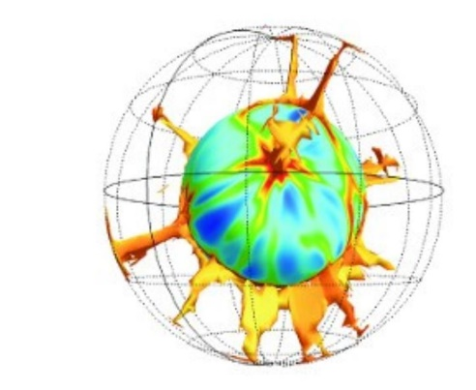
lnw@umd.edu

EDUCATION
University of Maryland
Ph.D. Geology, in progress (anticipated graduation: May 2023)
University of California Santa Barbara
M.S. Earth Science, 2019
B.A. Chemistry, 2016
B.S. Biological psychology, 2016
Minor, Earth Science, 2016

AWARDs, Grants, & Fellowships
Dean’s Fellowship Award, University of Maryland College Park, 2019
Earth System Science Interdisciplinary Center (ESSIC) Student Travel Award, 2019
George Tunnel Endowed Fellowship, Department of Earth Science, UCSB, 2019
Global Field Travel Award, Department of Earth Science, UCSB, 2019
Service to Undergraduate and Graduate Well-Being Award, Royal Geologic Society of Goleta, 2019
Grad Slam! Winner for best oral presentation, Department of Earth Science, UCSB, 2018
Preston Cloud Award, Department of Earth Science, UCSB, 2018
Graduate Research Grant, Geological Society of America, 2018
Conference Travel Grant, Graduate Student Association, UCSB, 2018
Undergraduate Research and Creative Studies Grant, UCSB 2016
Phi Lamda Upsilon Award, Department of Chemistry and Biochemistry, UCSB, 2016

ACADEMIC EXPERIENCE
Invited talk: Lunar Exploration Assessment Group (LEAG) Virtual Meeting February 7, 2020
Characterization of Regolith and Trace Economic Resources (CRATER) via NASA DALI Program

AGU Fall Meeting 2018 Oral Presentation December 10, 2018
The Icelandic Mantle Plume: A Sixty-Two Million-Year Record of the Deep Mantle

NASA Jet Propulsion Laboratory
Applied Science and Systems Engineering Intern: AIRS Mission June 2018-August 2018
Applied data visualization techniques to atmospheric and weather data from the AIRS instrument on the Aqua satellite. 40-60 hours/week

Non-Traditional Stable Isotope Short Course, Mineralogical Society of America, Lawrence Berkeley National Laboratory
Attendee December 2016
Attended the series of talks and discussions about non-traditional isotope geochemistry, method development, isotope theory, and applications of isotope chemistry.

High Temperature Isotope Geochemistry, University of California Santa Barbara
Undergraduate Research Assistant April 2016 – June 2017
The goal of this project was to inspect the geochemical evolution in a suite of Icelandic lavas. Project includes mineral collection; analyses of isotope, major, and trace element data; and discussion of pertinent literature. Hrs/week varied.

Stable Isotope Laboratory, University of California Santa Barbara
Undergraduate Research Assistant December 2016 – February 2017
Performing various sample preparations and chemical analyses of stalagmite samples. Includes collaboration with many departments and labs on campus including Materials Science and Marine Sciences. 5-10 hours/week.

UCSB Education Abroad Program
Program Participant at the University of Victoria in Wellington, New Zealand February 2015 – June 2015
Took advantage of new and diverse cultural, political, and educational experiences through the study abroad program.

Neuropharmacology Lab, University of California Santa Barbara
Undergraduate Research Assistant January 2014 – March 2014
Worked independently performing Western Blotting techniques including preparation and execution of electrophoresis, blocking and antibody incubation, and developing film. 10-15 hours/week.

META Lab, University of California Santa Barbara
Undergraduate Research Assistant December 2012 – October 2013
Worked with participants in a cognitive psychology to collect EEG and other physiological data during mental time travel tasks. 6 hours/week

WORK and VOLUNTEER EXPERIENCE
Kids Excelling in Math and Science (KEMS) Outreach
Volunteer January 2020 – present
Weekly science outreach at Hyattsville Middle School. KEMS volunteers create lessons plans each week that include hands on activities, lectures, videos, etc.

Senior Dog Sanctuary November 2020-present
Volunteer
Take care of shelter dogs on weekends.

Campus Learning Assistance Services, University of California Santa Barbara
ACE Chemistry and Academic Skills Tutor September 2016 – June 2017
Work closely with Academic Skills instructors as well as professors within the Department of Chemistry and Biochemistry to lesson plan and teach general chemistry and successful study skills to first generation college students and/or students from low Academic Performance Index high schools who come from backgrounds with limited resources. 10 hours/week

Science Night Outreach
Volunteer September 2017 – June 2019
Volunteer at local elementary school science nights to teach young students about geology including minerals, rocks, fossils, earthquakes, etc.

Skills
Computer Skills
Proficient with MATLAB, Mathematica, Microsoft Word, Excel, Powerpoint, Adobe Illustrator. Familiar with Python.

Laboratory techniques
Column chromatography in a clean lab, thermal ionization mass spectrometry, Orbitrap mass spectrometry, electron probe microanalysis, scanning electron microscopy, simple and fractional distillation, titration, gravimetric analysis, etc.

Hobbies and interests
Reading and writing, both academically and for fun. Learning and teaching are both passions of mine. I am extremely passionate about education, mental health, making science accessible to everyone, and animal welfare. Backpacking, camping, rock-climbing, exploring outdoors, and travelling.

MEMBERSHIPS
Geochemical Society Mineralogical Society of America American Geophysical Union Association of Women Geologists Geological Society of America Women in Science and Engineering Club

Publications
Willhite, L. N., Jackson, M. G., Blichert‐Toft, J., Bindeman, I., Kurz, M. D., Halldórsson, S. A., et al. (2019). Hot and heterogenous high‐³He/⁴He components: New constraints from proto‐Iceland plume lavas from Baffin Island. Geochemistry, Geophysics, Geosystems, 20. https://doi.org/10.1029/2019GC008654

